

Atlantic Academy
School Uniform Policy



Reviewed by: Board
Last reviewed: July 2026
Due for review: July 2027
Version: 1.1

1. Aims
This policy aims to:
- Set out our approach to requiring a uniform that is of reasonable cost and offers the best value for money for parents and carers
- Avoid discrimination in line with our legal duties under the Equality Act 2010
- Clarify our expectations for school uniform

2. Our school’s legal duties under the Equality Act 2010
The Equality Act 2010 prohibits discrimination against an individual based on the protected characteristics, which include age, sex, disability, race, religion or belief, pregnancy and maternity, and gender reassignment.
To avoid discrimination, our school will allow for reasonable adaptations to our policy on the grounds of equality by asking pupils or their parents/carers to get in touch with Averill Jewell - ajewell@atlanticacademy.uk, who can answer questions about the policy and respond to any requests. These will be considered on a case-by-case basis.

3. Limiting the cost of school uniform
Our school has a duty to make sure that the uniform we require is affordable, in line with statutory guidance from the Department for Education (DfE) on the cost of school uniform.
We understand that items with distinctive characteristics (such as branded items, or items that need to have a school logo or a unique fabric/colour/design) cannot be purchased from a wide range of retailers and that requiring many such items limits parents/carers’ ability to ‘shop around’ for a low price.
We will make sure our uniform:
- Is available at a reasonable cost
- Provides the best value for money for parents/carers
We will do this by:
- Carefully considering whether any items with distinctive characteristics are necessary
- Limiting any items with distinctive characteristics, where possible.
- Limiting items with distinctive characteristics to low-cost and/or long-lasting items, such as ties
- Avoiding specific requirements for items pupils could wear on non-school days, such as coats, bags and shoes
- Keeping the number of optional branded items to a minimum, so that the school’s uniform can act as a social leveller
- Avoiding different uniform requirements for different years/classes/house groups
- Avoiding different uniform requirements for extra-curricular activities
- Considering alternative methods for signalling differences in groups for inter-school competitions, such as creating posters or labels
- Making sure that arrangements are in place for parents/carers to acquire second-hand uniform items
- Avoiding frequent changes to uniform specifications and minimising the financial impact on parents/carers of any changes
- Consulting with parents/carers and pupils on any proposed significant changes to the uniform policy, and carefully considering any complaints about the policy

4. Expectations for school uniform
4.1 Our school’s uniform
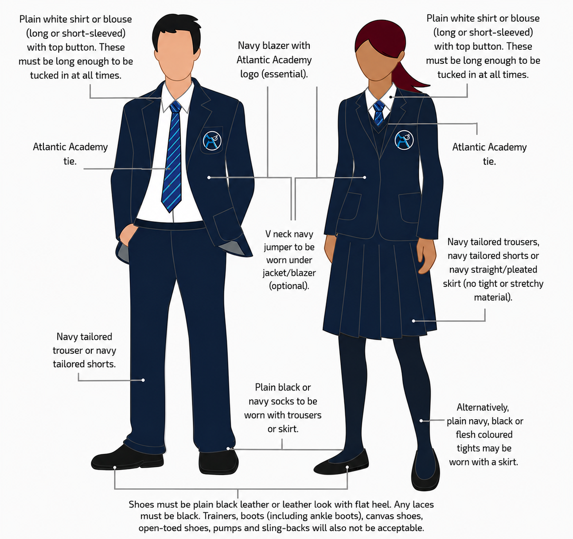

Uniform

- Blazer: Atlantic Academy navy blazer (Required - Price & Buckland).
- Tie: Atlantic Academy traditional or clip-on tie (Required - Price & Buckland).
- Jumper: Atlantic Academy navy v-neck jumper (Optional - Price & Buckland). Please note: unbranded jumpers are not permitted, but students may choose to wear just a shirt and blazer.
- Shirt: Plain white collared shirt (long or short-sleeved).
- Bottoms: Plain navy trousers, a navy knee-length skirt, or tailored navy shorts.
- Footwear: Plain, entirely black leather or leather-look shoes (no visible coloured logos or white soles). Ankle boots are not permitted. Footwear exemptions would be for medical reasons only.
- Socks/Tights: Plain navy or black.
- During cold/wet weather students are encouraged to wear an outside, waterproof coat for travel to college and when outside at break. These will need to be removed when inside the building.

Skirts, Trousers and Shorts

These can be purchased from any supplier.
Shorts must be tailored and knee length.
Trousers must be worn around the waist - a plain black or navy belt is allowed. They must be long enough to sit on top of shoes and not be ankle length.
Skirts must also be knee length.

PE Kit
- Top: Atlantic Academy polo shirt or long-sleeved top (Price & Buckland) OR plain navy sports top. (t-shirt or polo shirt)
- Bottoms: Atlantic Academy tracksuit bottoms/shorts (Price & Buckland) OR plain navy tracksuit bottoms/shorts.
- Outerwear: Plain navy sweatshirt
- Footwear & Socks: Supportive sports trainers and plain navy or black socks.
Jewellery, hair & make up
A watch is permitted. No rings, bracelets or necklaces are allowed. One single, plain stud in each ear is allowed. Studs in noses or any other part of the face are not allowed and students will be asked to remove these before coming into school.
Hair must be of natural colour. If the hair is below shoulder-length then it should be tied back for all practical lessons or where health and safety require it. Shaving of any part of the head is not accepted, nor is the use of gel allowed to create unusual styles.
Coloured nail varnish and false eyelashes are not permitted in school. Gel or acrylic nails or shellac polish are also not permitted. Excessive makeup will need to be removed.

4.2 Where to purchase it
Approved Suppliers

We recommend you buy the uniform through the School supplier to ensure that these meet the School expectations and to avoid an item of uniform not meeting requirements. However, these items can also be purchased from alternate suppliers, should you wish to do so. Please use the following to access the Atlantic Academy section on our uniform supplier’s website https://price-buckland.co.uk/atlantic-academy-bideford


Information about second-hand uniform
Second hand uniform is available from Atlantic Academy - please contact Mrs Evans - eevans@atlanticacademy.uk
There are also two Facebook pages;-
- Atlantic Academy (Bideford) Uniform
- Atlantic Academy Uniform Sale or Exchange

5. Expectations for our school community
5.1 Pupils
Pupils are expected to wear the correct uniform at all times (other than specified non-school uniform days) while:
- On the school premises
- Travelling to and from school
- At out-of-school events or on trips that are organised by the school, or where they are representing the school (if required)
Pupils are also expected to contact Averill Jewell - ajewell@atlanticacademy.uk if they want to request an adaptation of the uniform policy in relation to their protected characteristics.
5.2 Parents and carers
Parents and carers are expected to make sure their child has the correct uniform and PE kit, and that every item is:
- Clean
- Clearly labelled with the child’s name
- In good condition
Parents/carers are also expected to contact Averill Jewell - ajewell@atlanticacademy.uk if they want to request an adaptation of the uniform policy in relation to:
- Their child’s protected characteristics
- The cost of the uniform
Parents/carers are expected to lodge any complaints or objections relating to the school uniform in a timely and reasonable manner.
Disputes about the cost of the school uniform will be:
- Resolved locally
- Dealt with in accordance with our school’s complaints policy
The school will work closely with parents/carers to arrive at a mutually acceptable outcome.
5.3 Staff
Staff will closely monitor pupils to make sure they are in the correct uniform. They will give any pupils and their parents/carers breaching the uniform policy the opportunity to comply, but will follow up with the headteacher if the situation doesn’t improve.
Ongoing breaches of our uniform policy will be dealt with by following our behaviour policy
In cases where it is suspected that financial hardship has resulted in a pupil not complying with this uniform policy, staff will take a mindful and considerate approach to resolving the situation.
5.4 Governors
The governing board will review this policy and make sure that it:
- Is appropriate for our school’s context
- Is implemented fairly across the school
- Takes into account the views of parents/carers and pupils
- Offers a uniform that is appropriate, practical and safe for all pupils
The governing body will also make sure that the school’s uniform supplier arrangements give the highest priority to cost and value for money, for example by avoiding single supplier contracts and by re-tendering contracts regularly. The governing body will ensure that information about secondhand uniform is available for parents/carers.
6. Links to other policies
This policy is linked to our:
- Behaviour policy
- Equality information and objectives statement
- Anti-bullying policy
- Complaints procedure

